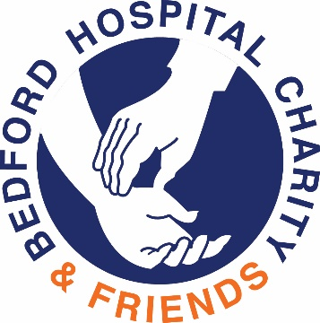
Bedford Hospital Charity & Friends
Making the difference for patients and carers

Please sponsor me (name)……………………………………………………….
To (event)……………………………………………………………………………….
In aid of Bedford Hospital Charity & Friends……………………………………………………..…Appeal
If I have ticked the box headed Gift Aid I confirm that I am a UK Income or Capital Gains taxpayer. I have read this statement and want Bedford Hospital Charity & Friends to reclaim tax on the donation detailed below, given on the date shown. I understand that if I pay less Income Tax/or Capital Gains tax in the current year than the amount of Gift Aid claimed on all my donations it is my responsibility to pay the difference. I understand the Charity will reclaim 25p of tax on every £1 that I have given.

Remember – You must provide your full name, home address, postcode and √ Gift Aid for the Charity to claim tax back on your donation.

Full name  (first name and surname) | Home address and postcode  (not your work address) | Amount £ | Date Paid | Gift Aid?  √
Full name  (first name and surname) | Home address and postcode  Not your work address | Amount £ | Date paid | Gift Aid?  √

